
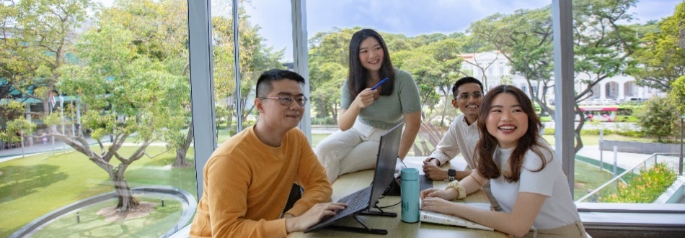

SME Consulting Programme
Project 3 - Brand Audit & Strategies

Brief Company Profile
Founded in 1981, this premier Singaporean horticultural group evolved from a founder’s childhood passion for nature into a leading industry powerhouse. Despite early challenges with land redevelopment, the company expanded through strategic acquisitions, transforming a small backyard operation into a multi-award-winning enterprise. Today, it serves a diverse clientele ranging from government agencies and corporate partners to retail gardening enthusiasts. By blending high-volume sourcing with a customer-first philosophy, the group provides affordable, sustainable greenery and landscaping services. Committed to community building, they remain dedicated to their mission of bringing vibrant plant life into every Singaporean home and office.

Objective of the Consulting Project
To conduct a comprehensive brand audit and develop strategic recommendations to strengthen the brand identity, positioning, and awareness, with the aim of improving top-of-mind recall and expanding relevance across both B2B and lifestyle-oriented segments.

Project Scope
Expected deliverables from Student Consultants:
1. Brand Audit
- Conduct an audit of the brand’s identity, positioning, messaging, and visual/communication consistency
- Review existing marketing and branding efforts across channels
- Identify gaps between intended positioning vs actual customer perception, and messaging consistency

2. Market & Competitor Analysis
- Evaluate and benchmark against key competitors
- Identify relevant market trends, gaps, and differentiation opportunities

3. Customer Insights
- Analysis of customer journey and key touchpoints
- Identify pain points and moments of opportunity within the overall brand experience

4. Brand Strategy Development
- Refine or enhance the brand positioning
- Develop brand personality and messaging framework
- Provide strategic recommendations to improve brand clarity, recall, and relevance

Student Requirements
- A 3-member team with at least two students majoring in Marketing would be advantageous.
- The team will be mentored by a Project Advisor.

More Information
Start Date: ASAP
Duration of project: Minimally 20 working weeks
Stipend: $3000 per team (excluding incidental expenses incurred during the
course of the project)
Working hours: Flexible working hours
Internship filing: Up to 10 weeks

*Only applicable to undergraduates from the Lee Kong Chian School of Business, School of Economics and School of Social Sciences.

